*CASE STUDY ON MACROECONOMIC VARIABLES*

*LEBANON*

GAYATHRIE

Date of Submission

17/09/2022

Submitted to

DR. JOSHY KJ



MA APPLIED ECONOMICS

DEPARTMENT OF ECONOMICS

CHRIST (DEEMED TO BE UNIVERSITY)

August 2022

INTRODUCTION

Lebanon is one of the smallest countries on the Asian continent and covers an area of ​​10,400 square kilo meters. Lebanon has 6.1 million inhabitants, including refugees from Syria and Palestine. Lebanon has a very challenging economy. The main reason for this is political and economic instability. The economy in 2022 is considered stagnant. The current hyperinflation and commodity shortages are making the economy more difficult. The economy is growing by 0.1%, which is 2.3% less than the expected growth for 2023. Prior to the civil war, Lebanon's economy was dynamic. During that time, the service sector was growing at the faster pace. Lebanon is in a severe economic crisis as a result of debt that was accumulated by previous governments following the civil war. 2019 saw the financial collapse of Lebanon, which was made worse by the pandemic. The banking industry is paralysed and unable to pay returns for the dollar accounts and the money they have now is only worth a very small fraction of what it was originally worth. Lebanon, once known as the Switzerland of the Middle East, is currently burdened with debt that is equivalent to 150% of national output. Lebanon attempted to recover from the effects of the civil war through the tourism industry, foreign aid, Lebanese citizens who work abroad, and the banking sector by offering high returns for dollar deposits. On August 4, 2020, stored ammonium explosion in Lebanon's capital city , Beirut resulted in killing people near 200 and  more than 6000 were seriously injured. Many claimed that the explosion was caused by government's corruption and poor management. In addition to the ongoing financial crisis, officials have estimated that the explosion may have resulted in economic losses of $15 billion.

The causes of the recent financial crisis will be covered in the section that follows, along with the impact it had on the Lebanese economy through the lens of four macroeconomic variables.

INCOME

A nation's wealth is defined by its national income, which also represents the value of the goods and services that the economy produces. National income data are used to calculate a country's overall economic performance. Its GDP dropped from about $55 billion in 2018 to about $35 billion in 2020 due to the collapse of the economy, and according to various estimates, it will be between $22 and $24 billion in 2021 which is less than 0.01 percent of the global economy’s GDP ,such a harsh contraction is typically connected to battles or wars.. In 2022, it continues to drop rapidly. The poverty rate increased from 30%–35% in 2019 to 85%–90% at the end of 2021, providing a clear picture of the extent to which the middle class has been crushed. In 2021, government revenue is predicted to drop by almost half to 6.6% of GDP, which would rank third-lowest in the world behind Somalia and Yemen. The sharp reductions in essential spending, which fuelled the economic spiral, contributed to the spending contraction becoming even more pronounced. Lebanon will rank fourth in the world for its debt-to-GDP ratio, when its total debt reaches 183% of GDP by 2021. When the value of currency plummeted, falling from 1,500 to the dollar before the crisis to about 23,000 in late January 2022, the government planned to impose a tax on WhatsApp calls, which sparked widespread protests. The Beirut incident and pandemic fuelled the economic crisis, which caused the Lebanese economy to contract.

GDP growth (annual %) – Lebanon 2000-2020

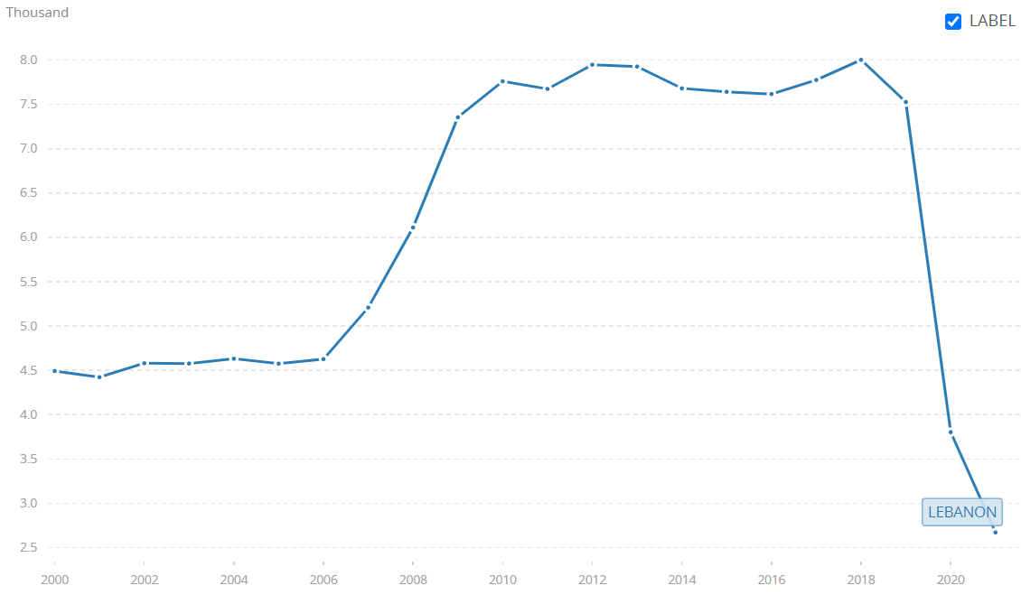

Source: World Bank national accounts data

GDP growth percentage of 2016 which was a slight increase from 2015.After 2017 growth became negative and it sharply declined to -25.908 during financial crisis(2019)

CONSUMPTION

Consumption is the use of goods and services by a nation. It plays a significant role in determining GDP. Consumption patterns provide insight into total national output, which is used to analyse market macroeconomic fluctuations. Macroeconomists will be able to better understand consumer spending patterns and the relationships between various consumption factors with the aid of household consumption data.

In 2020, households and NPISHs in Lebanon reported final consumption expenditure of 69602412438 USD (current international $) according to data collected by world bank. Two consumer groups make up the Lebanese economy. One group consists of people earning Lebanese pounds who are struggling to make ends meet as food prices increased by more than 400 percentage while salaries stayed the same and soared. Lebanese people's purchasing power has significantly decreased. Due to the worst financial crisis in decades, Lebanon's consumer price inflation rate increased to an all-time high of 145.8% year-over-year in December 2020 from 133.5% the previous month. Additionally, there was a significant increase in food prices (402.3%) and transportation costs (206%), which put additional pressure on a wide range of businesses such as restaurants, hotels, clothing, home furnishings, and other miscellaneous goods and services. People earning US dollars or comparable currencies make up the second group and they have higher purchasing power than first group earning Lebanese pounds. The financial crisis is making it difficult for suppliers to pay their outstanding balances. It used to be common practise to buy items from suppliers by retailers without paying upfront, and they would give you 60 to 90 days to pay for the items. The majority of suppliers now demand payment upon delivery or within a week at most, which has decreased the value of stock due to concerns about the Lebanese pound's potential for runaway devaluation. In addition, supplier product portfolios are being condensed to only contain "fast moving" imports and as many locally produced goods as are feasible. To make up for the loss from imports, suppliers started to choose local brands. Only a small percentage of Lebanese citizens can afford electricity and clean water. People only have access to electricity for a few hours a day because the country can no longer provide it for a full day. The country's electricity production and water supply network and its maintenance are getting worse because of the country's economic instability, rising fuel prices due to its weak currency, removal of government subsidies, Covid -19 and the conflict between Russia and Ukraine.

Gross domestic consumption (% of GDP) 2000-2020

Source: World Bank national accounts data

Inflation, consumer prices (annual %) 2009-2020

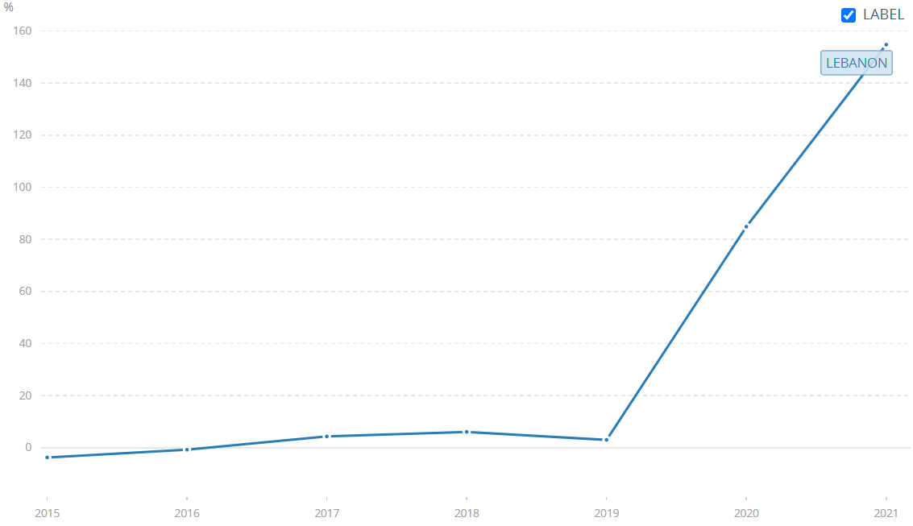

Source: World Bank national accounts data

Inflation rate was between -3 to 6 till 2019 and after 2019 it was a huge hike , 154.756 as affect of financial crisis and covid pandemic.

INVESTMENT

Foreign direct investment (FDI) is a key driver of economic expansion. FDI inflows increase technology transfer, domestic firm productivity, and the demand for financial capital, generating employment and promoting economic growth. From USD 2.52 billion in 2017 to USD 2.88 billion in 2018, FDI flows to Lebanon increased by 14%. However, from $2.6 billion the previous year, inflows decreased by 20% to $2.1 billion in 2019, the lowest level since 2002. 2019 saw a 3.8 percent increase in FDI inflows and a 0.8 percent decrease in FDI outflows for Lebanon's GDP. FDI outflows in 2019 decreased 33.6 percent compared to the prior year. According to UNCTAD (United Nations Conference on Trade and Development), exports rose by 26% and imports fell by 4% in 2019 compared to 2018. High levels of economic unpredictability and political instability enabled investors to delay and withdraw investment plans in Lebanon, which had a negative impact on private investment performance.

Gross domestic investment (% of GDP) 2000-2020

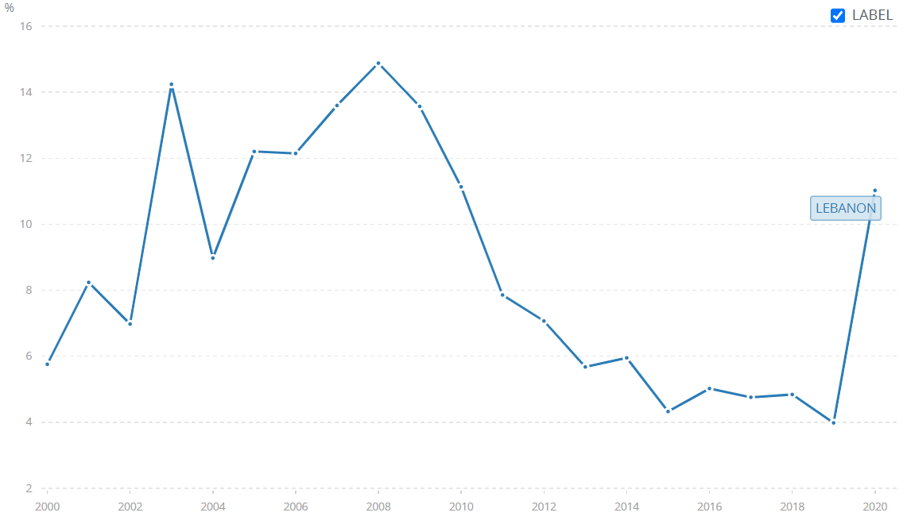

Source: World Bank national accounts data

FDI ,net inflows was highest during 2008(14.881) and it started to decline afterwards. Avery sharp fall in FDI, net inflows is visible in 2019, which was 3.981.

SAVINGS

GDP minus final consumption spending equals gross domestic savings. Savings from households, private entities, and the public sector make up gross domestic savings. According to data, Savings of Lebanon   have declined since 2008. Gross savings in Lebanon is calculated yearly and it was recorded as -9.3 in 2019 and -21.7 in 2020, which is the lowest value ever. The bank provided exceptional interest rates for new dollar deposits and extraordinary interest rates for Lebanese pounds until 2016. At the time, Lebanon's economy was totally dollarized, and a sufficient inflow of dollars enables the nation to fund and spend. Central bank of Lebanon offered lavish profits for deposits made in dollars and it increased dollar flow, which led in rising foreign reserves. Meanwhile, the country's liabilities were also growing, which led to an increase in Lebanon's debt, which now accounts for around a third or more of its budget spending. 2018's pre-election period saw politicians waste public funds even if the state didn't mandate it. Failure to reduce public spending led to a growth in debt, which then caused the country's foreign reserves to begin to disappear as a result of investors' declining faith in the Lebanese government. As a result, the nation was unable pay foreign depositors.

Source: World Bank national accounts data

Lebanon’s highest saving was 2.915 ,in 2009 and lowest ever after 2000 was -21.67 in 2020 .

RESEARCH QUESTION AND ANSWER

* What factors led to the Lebanese economy's collapse?

Lebanon, once referred to as the Switzerland of the Middle East, is now among the top 10 nations experiencing a severe economic crisis. The failure of the Lebanon economy was primarily caused by the government's uncontrolled spending after the civil war and its inability to reimburse its debts. Political parties misused the nation's resources for their own political gain and country's political and economic stability were adversely affected by changing governments and policies. Country's debt accumulation  was fuelled by lavish repayments to dollar accounts, which ultimately caused the country's financial sector to collapse in 2019. Middle East turmoil, the COVID 19 pandemic, and the Biuret explosion all contributed to the country's existing crisis.

* How did the financial crisis in 2019 affect the Lebanese economy ?

The Lebanese economy was hardly impacted by the financial crisis of 2019 and has not yet fully recovered.   Collapse of banking sector caused by a huge amount of debt resulted in devaluation of   Lebanese pound . After 2015, there is a noticeable slowdown in the economy, which grew worse in 2019 and after. GDP decreased in 2019 from $55 billion to $44 billion. Citizens and retailers were forced to switch to local brands as a result of high inflation rates that reduced their purchasing power. Lebanon used a large portion of its income for the production of energy. As a result, the government has been unable to provide the Lebanese people with uninterrupted access to clean water and electricity since 2019. In light of the financial sector's collapse, investors stepped down their investments from Lebanese economy. The country's reserves were hardly impacted by failure to repay investors, both domestic and foreign and it affected the Lebanese population’s ability to save.

CONCLUSION

It is evident from the previous section that the financial crisis had adverse impact on the economy of Lebanon, which resulted in a decline in the standard of living for Lebanese citizens and a rise in the level of poverty in the nation. The impacts of the crisis will take years to fully resolve. Rebuilding the financial sector and managing debt in a well-structured way are the only ways to achieve long-term recovery. A country's recovery will be only speeded up by stable politics and effective policy implementation.

BIBILOGRAPHY

(n.d.). Retrieved from https://www.worldbank.org/en/news/press-release/2022/01/24/lebanon-s-crisis-great-denial-in-the-deliberate-depression

(n.d.). Retrieved from https://data.worldbank.org/indicator/NY.GDP.MKTP.KD.ZG?locations=LB

(n.d.). Retrieved from https://www.reuters.com/world/middle-east/lebanese-govt-revenues-fell-by-nearly-half-2021-world-bank-says-2022-01-25/

Agriculture, T. U.-f. (2021). Financial and Economic Crises: The effect on Lebanon's FMCG Businesses.

Ichrаq, G. (2022). Lebanon, economic and financial crises, reasons for collapse. *Revue Française d’Economie et de Gestion ISSN : 2728- 0128 Volume 3 : Numéro 6*.

Snaije, B. (2022). Lebanon: Financial crisis or national collapse?